Project Design Phase-II
Technology Stack (Architecture & Stack)

Date | 26 February 2026
Team ID | LTVIP2026TMIDS74388
Project Name | LAPTOP REQUEST CATALOG ITEM
Maximum Marks | 4 Marks

Technical Architecture:
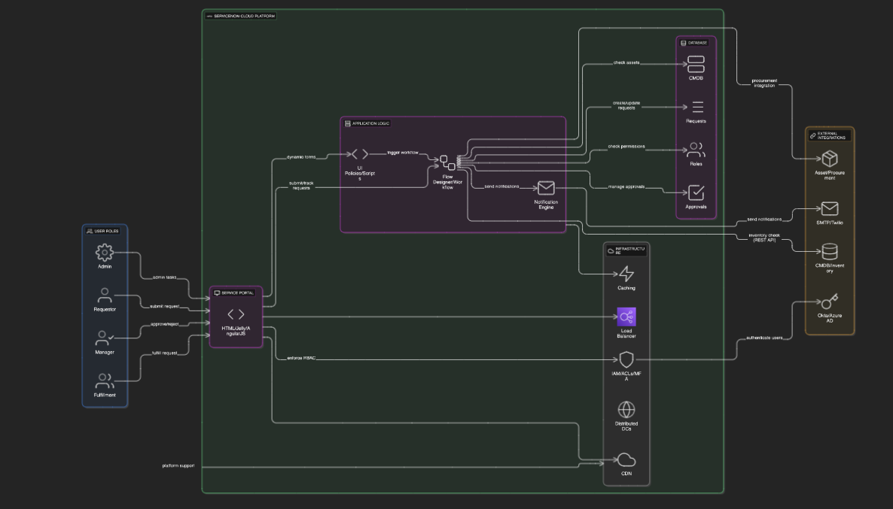
The Deliverable shall include the architectural diagram as below and the information as per the table1 & table 2
Table-1 : Components & Technologies:
S.No | Component | Description | Technology
 | User Interface | Web-based ServiceNow Service Catalog portal to submit requests | ServiceNow UI Framework (HTML, Jelly, AngularJS inside ServiceNow)
 | Application Logic-1 | Dynamic form behavior using UI Policies and Client Scripts | ServiceNow Server-side scripts (JavaScript, Glide API)
 | Application Logic-2 | Workflow automation and approval processing | ServiceNow Flow Designer / Workflow Engine
 | Application Logic-3 | Email notification and alert logic | ServiceNow Notification Engine
 | Database | Stores laptop request, approval, and user data | ServiceNow CMDB, Task and Request tables (MySQL-based backend)
 | External API-1 | Integration to fetch laptop availability from CMDB | ServiceNow REST API or OOTB CMDB APIs
 | Infrastructure (Server / Cloud) | ServiceNow Platform hosted on Cloud | ServiceNow Cloud SaaS Platform
Table-2: Application Characteristics:
S.No | Characteristics | Description | Technology
 | Open-Source Frameworks | ServiceNow platform leverages open-source components like AngularJS for UI, and JavaScript for client/server scripting. | AngularJS, JavaScript
 | Security Implementations | Role-based access control, multi-factor authentication, encryption of data at rest and in transit, OWASP best practices. | ServiceNow IAM, HTTPS, TLS, ACLs, OAuth2
 | Scalable Architecture | ServiceNow’s multi-tenant cloud architecture supports scalability with modular components and APIs following microservices principles. | ServiceNow Cloud Platform, REST APIs
 | Availability | High availability with geographically distributed data centers, automated failover, scheduled maintenance windows. | ServiceNow Cloud Infrastructure, Load Balancers
 | Performance | Optimized workflows, caching mechanisms within ServiceNow, and CDN services for static assets to ensure low latency and high throughput. | ServiceNow Caching Layer, CDN (Akamaized or similar)

